Producer Consumer Problem
Q. Write a C program to simulate:
Producer-Consumer problem using semaphores.

#include <stdio.h>

int mutex = 1;
int full = 0;
int empty = 2;
int x = 0;

void wait()
{
mutex--;
}

void signal()
{
mutex++;
}

void producer()
{
if (mutex == 1 && empty != 0)
{
wait();
full++;
empty--;
x++;

printf("Producer has produced: Item %d\n", x);

signal();
}
else
{
printf("Buffer is full!\n");
}
}

void consumer()
{
if (mutex == 1 && full != 0)
{
wait();
full--;
empty++;

printf("Consumer has consumed: Item %d\n", x);

x--;
signal();
}
else
{
printf("Buffer is empty!\n");
}
}

int main()
{
int choice;

while (1)
{
printf("\n1. Producer\n2. Consumer\n3. Exit\n");
printf("Enter your choice: ");
scanf("%d", &choice);

switch (choice)
{
case 1: producer(); break;
case 2: consumer(); break;
case 3: return 0;
default: printf("Invalid choice!\n");
}
}
}

Output:

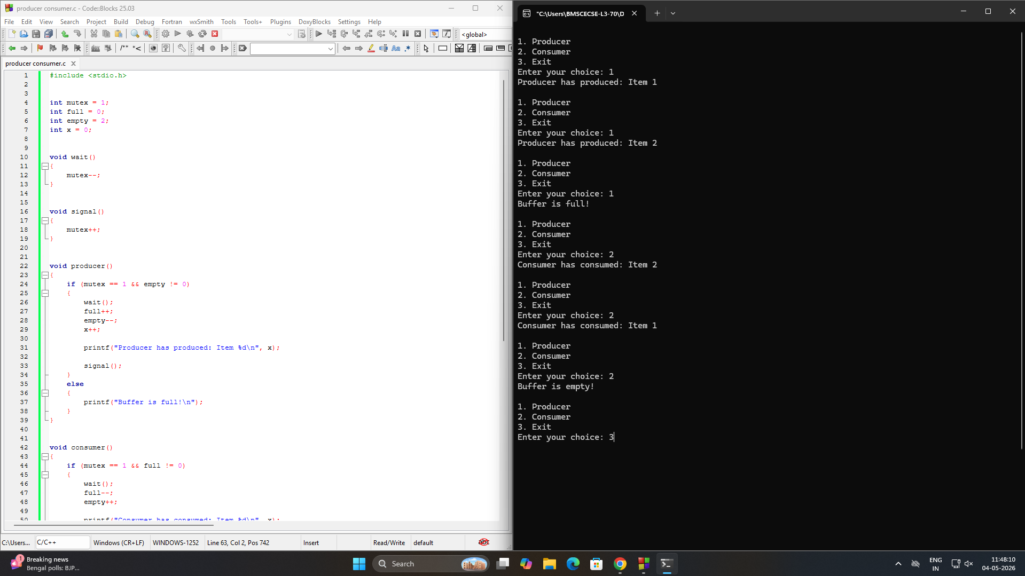

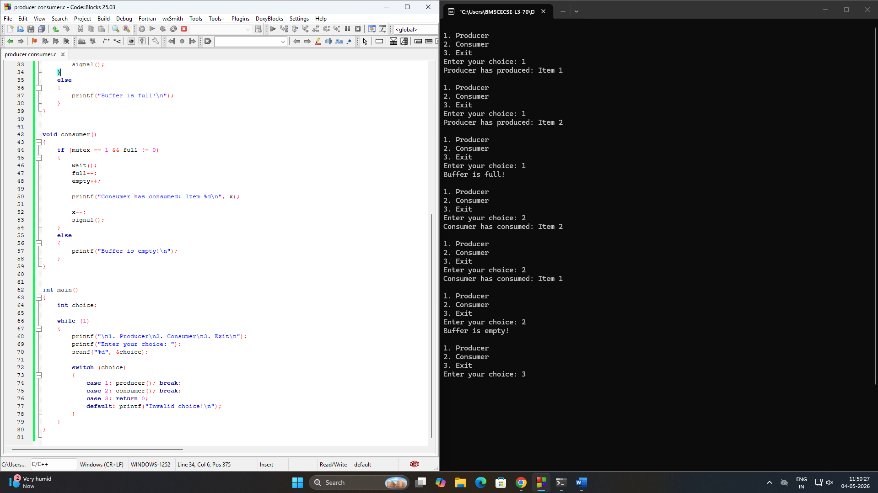

Q. Write a C program to simulate:
Dining-Philosopher’s problem
#include <stdio.h>
#include <semaphore.h>

#define N 5

sem_t chopstick[5];
sem_t room;

void wait_sem(sem_t *s) {
sem_wait(s);
}

void signal_sem(sem_t *s) {
sem_post(s);
}

void Philosopher(int i) {

printf("P %d is waiting\n", i);

wait_sem(&room);

wait_sem(&chopstick[i-1]);
wait_sem(&chopstick[i%5]);

printf("P %d is granted to eat\n", i);
printf("P %d has finished eating\n", i);

signal_sem(&chopstick[i-1]);
signal_sem(&chopstick[i%5]);

signal_sem(&room);
}

int main() {
int i, choice;

for(i = 0; i < 5; i++)
sem_init(&chopstick[i], 0, 1);

sem_init(&room, 0, 4);

while(1) {
printf("\n1. One can eat at a time\n");
printf("2. Two can eat at a time\n");
printf("3. Exit\n");
printf("Enter your choice: ");
scanf("%d", &choice);

if(choice == 3)
break;

if(choice == 1) {
printf("\nAllow one philosopher to eat at any time\n");

for(i = 1; i <= 5; i++) {
Philosopher(i);
}
}

else if(choice == 2) {
printf("\nAllow two philosophers to eat at same time\n");

for(i = 1; i <= 5; i += 2) {

printf("P %d is waiting\n", i);
if(i + 1 <= 5)
printf("P %d is waiting\n", i + 1);

printf("P %d is granted to eat\n", i);
if(i + 1 <= 5)
printf("P %d is granted to eat\n", i + 1);

printf("P %d has finished eating\n", i);
if(i + 1 <= 5)
printf("P %d has finished eating\n", i + 1);
}
}

else {
printf("Invalid choice\n");
}
}

return 0;
}

Output:

